**9. DESIGN OF LOW PASS FIR FILTER USING WINDOWS**

**% (a) To design a low pass FIR filter**

clc;

close;

wc=0.5*%pi;

N=13;

alpha=(N-1)/2;

app=0.000001;

n=0:1:N-1;

hlow=sin(wc*(n-alpha+app))./(%pi*(n-alpha+app));

*//rectangular window*

wr=1;

hn=hlow.*wr

disp('h(n)for rectangular window',hn);

*//Hanning window*

n=0:1:N-1;

w=.5- (0.5*cos((2*n*%pi)./(N-1)));

disp('hanning window sequence',w);

hn1=hlow.*w

disp('filter coefficients for hanning window - h(n)',hn1);

figure(1)

[hzm,fr]= frmag(hn,256) ;

subplot(2 ,1 ,1)

plot(2*fr, hzm)

xlabel( ' Normalized Digital Frequency w');

ylabel( 'Magnitude ');

title( ' Frequency Response oHanningf FIR LPFuing Recatangular Window ')

hzm_dB = 20* log10 (hzm);

subplot (2 ,1 ,2);

plot(2*fr , hzm_dB);

xlabel( ' Normalized Digital Frequency W' );

ylabel( 'Magnitude in dB');

figure(2)

[hzm1,fr1]= frmag(hn1,256) ;

subplot(2 ,1 ,1)

plot(2*fr1, hzm1)

xlabel( ' Normalized Digital Frequency w');

ylabel( 'Magnitude ');

title( ' Frequency Response of FIR LPF using Hanning Window ')

hzm1_dB = 20* log10 (hzm1);

subplot (2 ,1 ,2);

plot(2*fr1 , hzm1_dB);

xlabel( ' Normalized Digital Frequency W' );

ylabel( 'Magnitude in dB');

title('Frequency Response of FIR LPF using Hanning Window');

**OUTPUT**

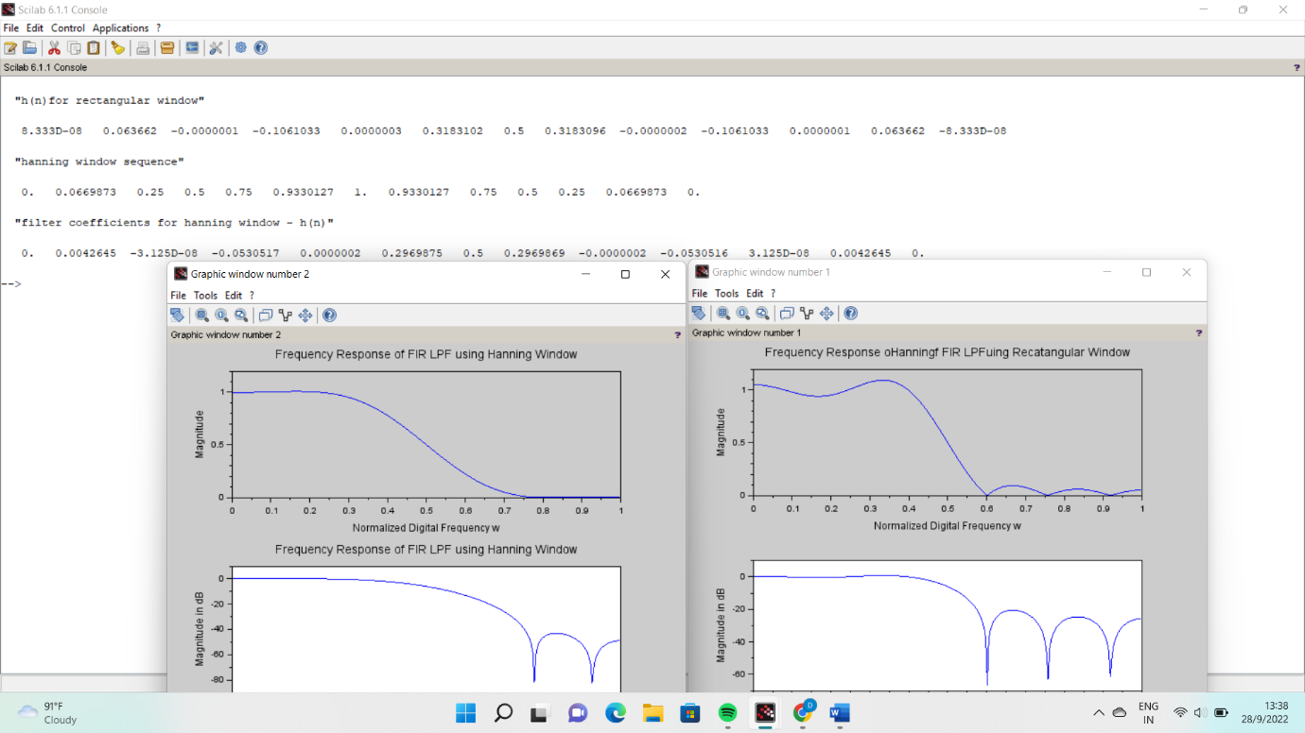

**% (a) To design a high pass FIR filter**

clc;

close;

wc=0.5*%pi;

N=9;

alpha=(N-1)/2;

app=0.0001;

n=0:1:N-1;

hhigh =(sin(%pi*(n-alpha+app)) - sin(wc*(n-alpha+app)))./(%pi*(n-alpha+app));

*//rectangular window*

wr=1;

hn=hhigh.*wr

disp('h(n)for rectangular window',hn);

*//Hamming window*

n=0:1:N-1;

w=.54- (0.46*cos((2*n*%pi)./(N-1)));

disp('hamming window sequence',w);

hn1=hhigh.*w

disp('filter coefficients for hamming window - h(n)',hn1);

figure(1)

[hzm,fr]= frmag(hn,256) ;

subplot(2 ,1 ,1)

plot(2*fr, hzm)

xlabel( ' Normalized Digital Frequency w');

ylabel( 'Magnitude ');

title( ' Frequency Response FIR HPF uing Recatangular Window ')

hzm_dB = 20* log10 (hzm);

subplot (2 ,1 ,2);

plot(2*fr , hzm_dB);

xlabel( ' Normalized Digital Frequency W' );

ylabel( 'Magnitude in dB');

figure(2)

[hzm1,fr1]= frmag(hn1,256) ;

subplot(2 ,1 ,1)

plot(2*fr1, hzm1)

xlabel( ' Normalized Digital Frequency w');

ylabel( 'Magnitude ');

title( ' Frequency Response of FIR HPF using Hamming Window ')

hzm1_dB = 20* log10 (hzm1);

subplot (2 ,1 ,2);

plot(2*fr1 , hzm1_dB);

xlabel( ' Normalized Digital Frequency W' );

ylabel( 'Magnitude in dB');

title('Frequency Response of FIR HPF using Hamming Window');

**OUTPUT**

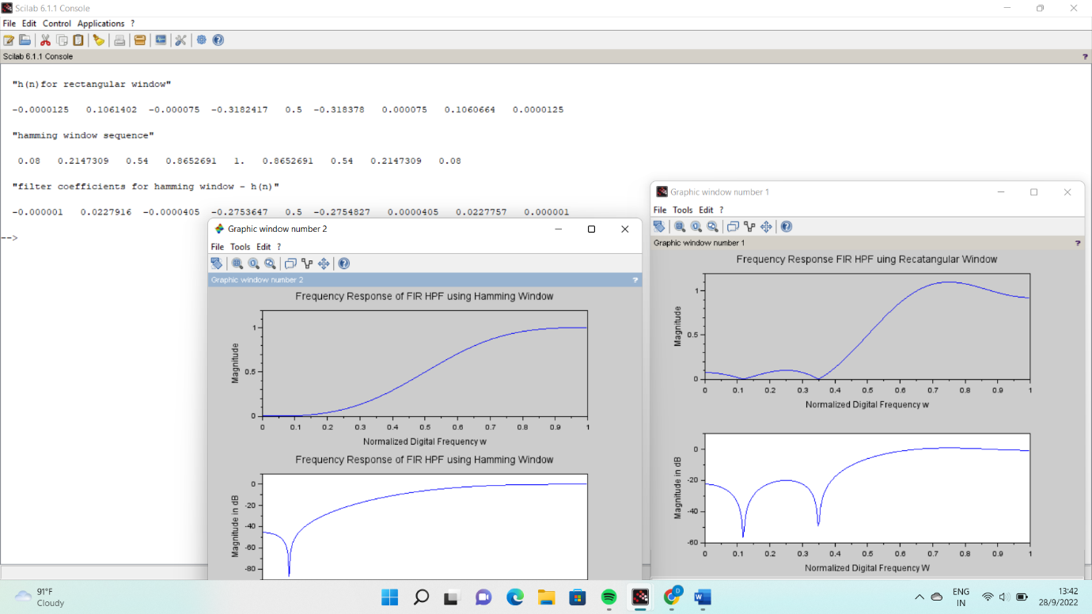

**10. DESIGN OF BAND PASS and BAND STOP FIR FILTER USING WINDOWS**

// Design a band pass filter:

clc;

close;

wc1=0.25*%pi;

wc2=0.75*%pi;

N=9;

alpha=(N-1)/2;

app=0.0001;

n=0:1:N-1;

hbpf=(sin(wc2*(n-alpha+app))-sin(wc1*(n-alpha+app)))./(%pi*(n-alpha+app));

*//rectangular window*

wr=1;

hn=hbpf.*wr

disp('h(n)for rectangular window',hn);

*//Hamming window*

n=0:1:N-1;

w=.54- (0.46*cos((2*n*%pi)./(N-1)));

disp('hamming window sequence',w);

hn1=hbpf.*w

disp('filter coefficients for hamming window - h(n)',hn1);

figure(1)

[hzm,fr]= frmag(hn,256) ;

subplot(2 ,1 ,1)

plot(2*fr, hzm)

xlabel( ' Normalized Digital Frequency w');

ylabel( 'Magnitude ');

title( ' Frequency Response FIR BPF uing Recatangular Window ')

hzm_dB = 20* log10 (hzm);

subplot (2 ,1 ,2);

plot(2*fr , hzm_dB);

xlabel( ' Normalized Digital Frequency W' );

ylabel( 'Magnitude in dB');

figure(2)

[hzm1,fr1]= frmag(hn1,256) ;

subplot(2 ,1 ,1)

plot(2*fr1, hzm1)

xlabel( ' Normalized Digital Frequency w');

ylabel( 'Magnitude ');

title( ' Frequency Response of FIR BPF using Hamming Window ')

hzm1_dB = 20* log10 (hzm1);

subplot (2 ,1 ,2);

plot(2*fr1 , hzm1_dB);

xlabel( ' Normalized Digital Frequency W' );

ylabel( 'Magnitude in dB');

title('Frequency Response of FIR BPF using Hamming Window');

**OUTPUT**

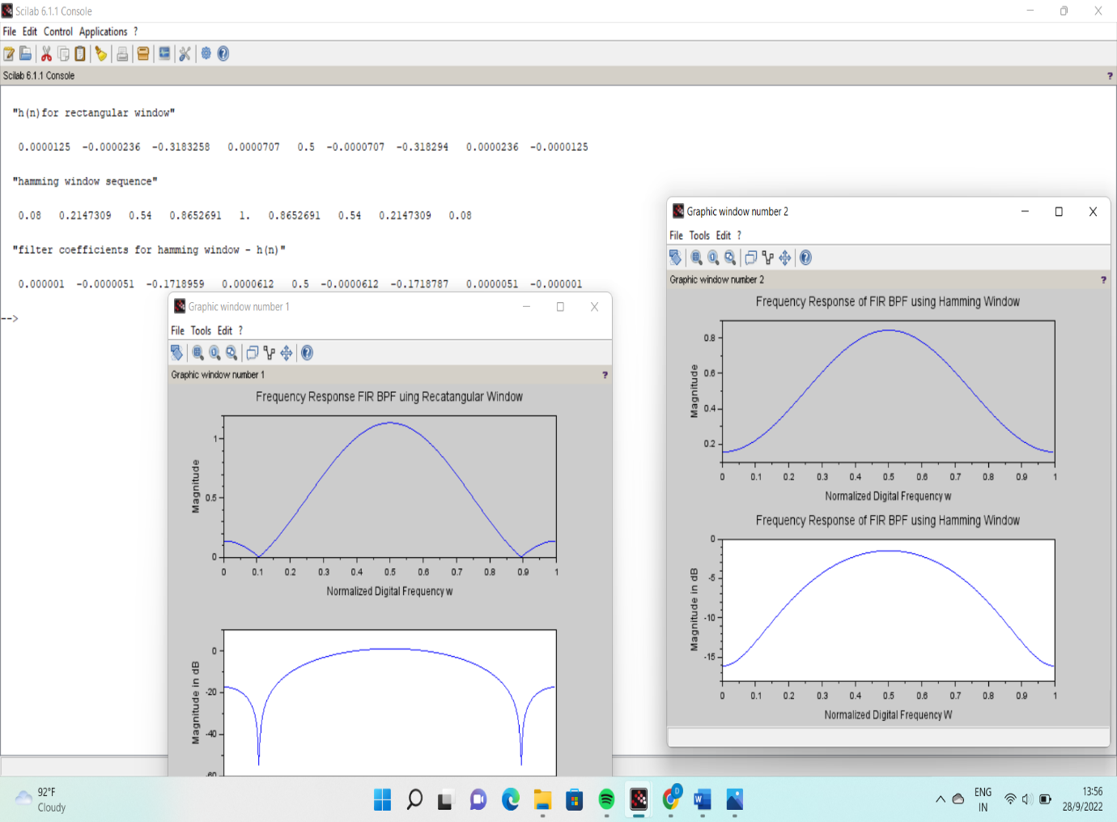

// b) To design Bandstop FIR filter

clc;

close;

wc=0.5*%pi;

N=13;

alpha=(N-1)/2;

app=0.000001;

n=0:1:N-1;

hbsf=(sin(%pi*(n-alpha+app))-sin(wc2*(n-alpha+app))+sin(wc1*(n-alpha+app)))./(%pi*(n-alpha+app));

*//rectangular window*

wr=1;

hn=hbsf.*wr

disp('h(n)for rectangular window',hn);

*//Hanning window*

n=0:1:N-1;

w=.5- (0.5*cos((2*n*%pi)./(N-1)));

disp('hanning window sequence',w);

hn1=hbsf.*w

disp('filter coefficients for hanning window - h(n)',hn1);

figure(1)

[hzm,fr]= frmag(hn,256) ;

subplot(2 ,1 ,1)

plot(2*fr, hzm)

xlabel( ' Normalized Digital Frequency w');

ylabel( 'Magnitude ');

title( ' Frequency Response of FIR BSF using Rectangular Window ')

hzm_dB = 20* log10 (hzm);

subplot (2 ,1 ,2);

plot(2*fr , hzm_dB);

xlabel( ' Normalized Digital Frequency W' );

ylabel( 'Magnitude in dB');

figure(2)

[hzm1,fr1]= frmag(hn1,256) ;

subplot(2 ,1 ,1)

plot(2*fr1, hzm1)

xlabel( ' Normalized Digital Frequency w');

ylabel( 'Magnitude ');

title( ' Frequency Response of FIR BSF using Hanning Window ')

hzm1_dB = 20* log10 (hzm1);

subplot (2 ,1 ,2);

plot(2*fr1 , hzm1_dB);

xlabel( ' Normalized Digital Frequency W' );

ylabel( 'Magnitude in dB');

title('Frequency Response of FIR BSF using Hanning Window');

**OUTPUT**

